Name : Tushar Pathak
Registration Number : 230905396
Roll Number : CSE6B-48
Week Num : 3

LAB 3 : CONSTRUCTION OF TOKEN GENERATOR

Q1) Write functions to identify the following tokens.
a. Arithmetic, relational and logical operators.
b. Special symbols, keywords, numerical constants, string literals and identifiers.

Code:
#include <stdio.h>
#include <ctype.h>
#include <string.h>

char keywords[][10] = {
"int","char","if","else","while","for","return","void"
};

int isKeyword(char str[]) {
for (int i = 0; i < 8; i++) {
if (strcmp(keywords[i], str) == 0)
return 1;
}
return 0;
}

int main() {
FILE *fp;
char ch, buf[20];
int i;

fp = fopen("Q1Input.c", "r");

while ((ch = fgetc(fp)) != EOF) {

/* Identifier and keyword */
if (isalpha(ch)) {
i = 0;
buf[i++] = ch;

while (isalnum(ch = fgetc(fp)))
buf[i++] = ch;

buf[i] = '\0';
ungetc(ch, fp);

if (isKeyword(buf))
printf("Keyword: %s\n", buf);
else
printf("Identifier: %s\n", buf);
}

/* Numeric constant */
else if (isdigit(ch)) {
i = 0;
buf[i++] = ch;

while (isdigit(ch = fgetc(fp)))
buf[i++] = ch;

buf[i] = '\0';
ungetc(ch, fp);

printf("Number: %s\n", buf);
}

/* Operators */
else if (strchr("+-*/%=<>!", ch)) {
printf("Operator: %c\n", ch);
}

/*special symbols*/
else if (strchr(";,(){}", ch)) {
printf("Special Symbol: %c\n", ch);
}
}
fclose(fp);
}

Q1Input.c
#include<stdio.h>
#include<stdlib.h>
int main(){
int a, b;
printf("Enter the numbers A and B...");
scanf("%d",&a,&b);
if(a>b){
printf("%d",a);
return a;
}else{
printf("%d",b);
return b;
}
}
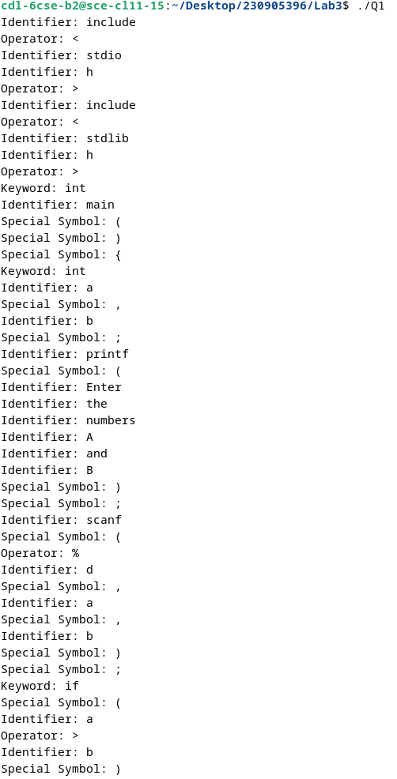
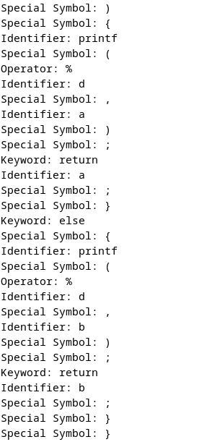
Output:

Q2) Design a lexical analyzer that includes a getNextToken() function for processing a simple C program. The analyzer should construct a token structure containing the row number, column number, and token type for each identified token. The getNextToken() function must ignore tokens located within singleline or multi-line comments, as well as those found inside string literals. Additionally, it should strip out preprocessor directives.

Code:
#include <stdio.h>
#include <ctype.h>
#include <string.h>

typedef struct {
char lexeme[30];
char type[30];
int row, col;
} Token;

char *keywords[] = {
"int","char","float","if","else","while","return",NULL
};

int isKeyword(char *str) {
for (int i = 0; keywords[i] != NULL; i++) {
if (strcmp(keywords[i], str) == 0)
return 1;
}
return 0;
}

Token getNextToken(FILE *fp) {
static int row = 1, col = 0;
Token t;
char c;
int i = 0;

while ((c = fgetc(fp)) != EOF) {
col++;

if (c == '\n') {
row++;
col = 0;
continue;
}

/* Ignore preprocessor */
if (c == '#') {
while (c != '\n')
c = fgetc(fp);
row++;
col = 0;
continue;
}

/* Ignore comments */
if (c == '/') {
char next = fgetc(fp);
if (next == '/') {
while (c != '\n')
c = fgetc(fp);
row++;
continue;
} else if (next == '*') {
while (!(c == '*' && fgetc(fp) == '/'))
c = fgetc(fp);
continue;
} else {
ungetc(next, fp);
}
}

/* Ignore string literals */
if (c == '"') {
while ((c = fgetc(fp)) != '"' && c != EOF);
continue;
}

/* Identifier and keyword */
if (isalpha(c)) {
i = 0;
t.lexeme[i++] = c;
while (isalnum(c = fgetc(fp))) {
t.lexeme[i++] = c;
col++;
}
t.lexeme[i] = '\0';
ungetc(c, fp);

strcpy(t.type, isKeyword(t.lexeme) ? "KEYWORD" : "IDENTIFIER");
t.row = row;
t.col = col - strlen(t.lexeme) + 1;
return t;
}

/* Number */
if (isdigit(c)) {
i = 0;
t.lexeme[i++] = c;
while (isdigit(c = fgetc(fp))) {
t.lexeme[i++] = c;
col++;
}
t.lexeme[i] = '\0';
ungetc(c, fp);

strcpy(t.type, "NUMBER");
t.row = row;
t.col = col - strlen(t.lexeme) + 1;
return t;
}

/* Operators */
if (strchr("+-*/<>=!", c)) {
t.lexeme[0] = c;
t.lexeme[1] = '\0';
strcpy(t.type, "OPERATOR");
t.row = row;
t.col = col;
return t;
}

/* Special Symbols */
if (strchr(";(){}[],", c)) {
t.lexeme[0] = c;
t.lexeme[1] = '\0';
strcpy(t.type, "SPECIAL SYMBOL");
t.row = row;
t.col = col;
return t;
}
}

strcpy(t.type, "EOF");
return t;
}

int main() {
FILE *fp = fopen("Q1Input.c", "r");
Token t;

while (strcmp((t = getNextToken(fp)).type, "EOF") != 0)
printf("%s %s %d %d\n", t.lexeme, t.type, t.row, t.col);

fclose(fp);
return 0;
}

Q1Input.c
#include<stdio.h>
#include<stdlib.h>
int main(){
int a, b;
printf("Enter the numbers A and B...");
scanf("%d",&a,&b);
if(a>b){
printf("%d",a);
return a;
}else{
printf("%d",b);
return b;
}
}

Output:

